[Exam-Python] Midterm

# Input and output 25pts:

For this section create a single script file named myIO.py

1. Ask the user to enter there first name using the input function
   1. The request string should look like this
      * “Please enter your first name: “
      * Store the response in a variable named ‘varFirstName’
2. Ask the user to enter there last name using the input function
   1. The request string should look like this
      * “Please enter your last name: “
      * Store the response in a variable named ‘varLastName’
3. Format and print the two variables that you set in step one and two.
   1. Your output string should be formatted like this
      * “Hello <varFirstName> <varLastName>, nice to meet you.”

# A1 [Screen Shot]: Take a screenshot of the code and the output of running the script.

# 

# Functions 25pts:

For this section create a single script file name “myFuctions.py”

1. Create an input function
   1. Create a function that takes no arguments and asks a user to enter a number.
      * Use this as the string to request a number from the user
        + “Enter a number: “
      * The function must convert the string representation of the number into an integer.
      * The function must ‘return’ the integer version of the number entered.
   2. From the main script call the function and print the return value to the screen

1. Create an output function
   1. Create a function that takes one argument and formats the string to look like this
      * **“You entered the number <your argument here>”**
      * You will get zero points for this question if you literally print out the words “<your argument here>”. This must be the formatted number you passed into the function as an argument.
      * There is no return value for this function
   2. From the main script call the function and print the formatted version of the string to the screen.
2. Create a data processing function
   1. Create a function that takes one argument and returns a value.
      * The function will take the number you pass in and add 100 to it.
   2. From the main script call the function using the number 5 and print the returned value string to the screen.
3. Bring all of the functions together in your script
   1. Use your input function to ask the user for input
   2. Use your data processing function to add 100 to the input value
   3. User your output function to print the processed value to the screen
   4. Run your script using the number 10

# A2 [Screen Shot]: Take a screenshot of the code and the output of running the script.

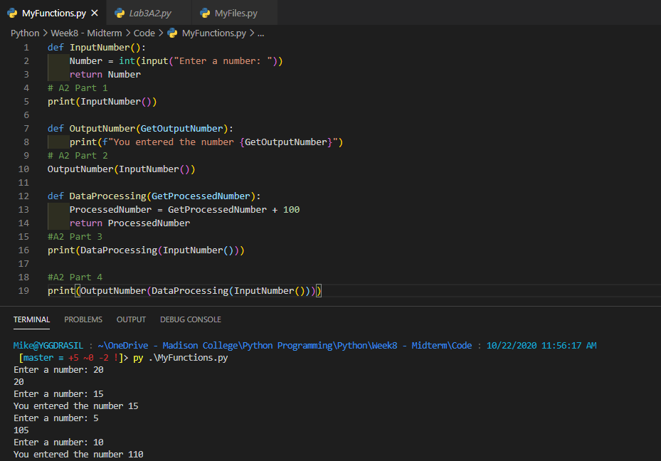

# 

# File interactions 25pts:

For this section create a single script file name “myFiles.py”

We will be using a text file for this question. Download the sample text file from google drive.

When you click the link the file will open in a document editor. To download

1. Click [PythonMidtermFile](https://docs.google.com/document/d/1PmUkb-T4lSam0cw92zrEUSfwV-XCmuyb-Uu_xDEhteg/edit?usp=sharing)
2. Go to ‘File -> Download -> Plain Text (.txt)’ in the editor toolbar.
3. Select ‘SaveFile” and click OK
4. cd Downloads
5. Using the ‘with’ statement, open the “PythonMidtermFile.txt” file and loop over the contents printing each line to the screen.
6. In your script, open the “PythonMidtermFile.txt” file using read only access and read the full file contents into a **str** data type variable named ‘strfiletext’ (Note: you will need to select the correct read function to return a string).
7. Use the len() function to print the file size to the screen.
8. Use the type() function to print the variable type to the screen.
9. In your script, open the “PythonMidtermFile.txt” file using read only access and save the full file contents to a **list** data type (Note: you will need to select the correct read function to return a list).
   1. Use the len() function to print the file size to the screen.
   2. Use the type() function to print the variable type to the screen.

# A3 [Screen Shot]: Take a screenshot of the code and the output of running the script.

A3 1

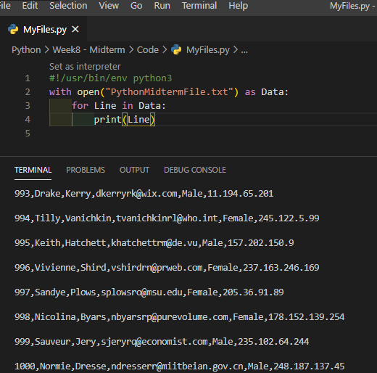

A3 2

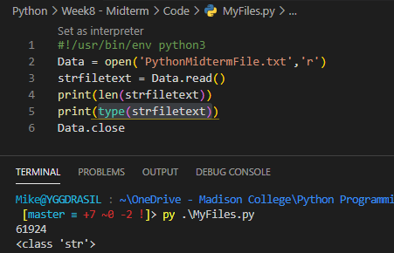

A3 3

